**Installation Guide**

# Database

1. Run the database script in the interview_db.sql file into Microsoft SQL Server

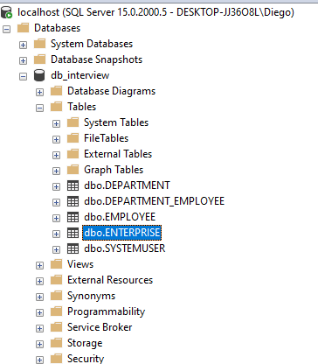

1. Set the connection String like the ones in your local pc. The file is Web.config

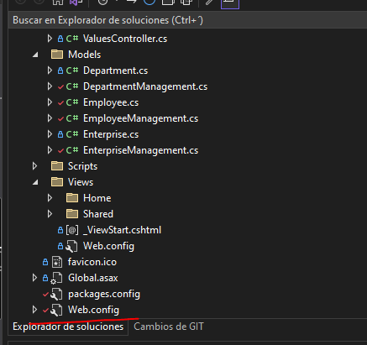

# Back End (.NET)

1. Open the folder interviewSICPA and the interviewSICPA.sln



1. Run the application with the IIS Express button

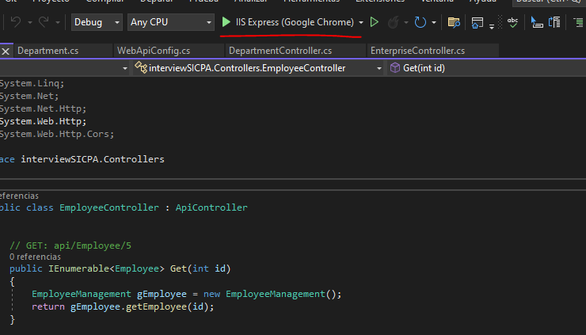

# Front end (Angular)

1. Go to the InterviewSICPA_FronEnd folder in a console and execute the “ng serve” command

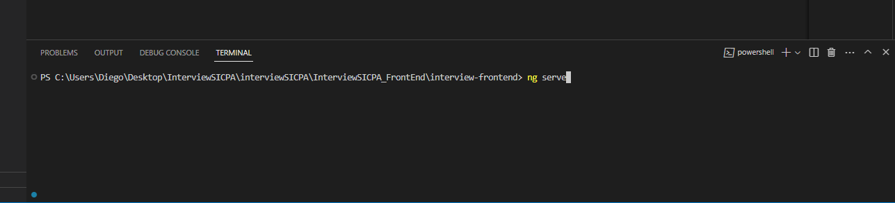

1. Open a web browser and write the next url <http://localhost:4200>

